CHAPTER 1
INTRODUCTION
  - DYSLEXIA: DEFINITION AND IMPACT
Dyslexia is a learning disorder that affects reading, writing, spelling, and language processing abilities. It is not related to intelligence but occurs due to differences in the way the brain processes written and spoken language. Students with dyslexia often experience difficulties in identifying letters, maintaining proper spacing, understanding words, and writing fluently. These challenges can affect academic performance, confidence, communication, and overall learning ability.
Traditional dyslexia diagnosis methods mainly depend on manual assessments conducted by teachers, psychologists, and therapists. These methods are often subjective, time-consuming, and difficult to scale for large numbers of students. In many educational institutions, especially in rural and low-resource areas, access to trained specialists is limited, leading to delayed diagnosis and intervention. Handwriting patterns provide important cognitive and motor information that can help identify dyslexic characteristics. Irregular spacing, inconsistent stroke patterns, letter reversals, and alignment problems are commonly observed in dyslexic handwriting. By analyzing these handwriting patterns using Artificial Intelligence (AI), early and accurate detection of dyslexia becomes possible.
The proposed system introduces a transparent AI-based dyslexia detection framework using handwriting analysis. The framework uses EfficientNet for feature extraction and Grad-CAM for explainable prediction visualization. The system also supports personalized exercises, progress monitoring, and report generation for educational and clinical applications.
  - IMPORTANCE OF EARLY DETECTION
Early detection of dyslexia is essential for improving academic performance and supporting students during the early stages of learning. When dyslexia is identified at an early age, students can receive proper educational guidance, personalized exercises, and specialized learning support to overcome writing and reading difficulties. Traditional diagnostic procedures require professional assessments, reading tests, and psychological evaluations,which are often slow and inaccessible in many regions. Delayed diagnosis may lead to poor academic performance, low confidence, emotional stress, and social difficulties.
Artificial Intelligence-based handwriting analysis provides an effective alternative for early dyslexia screening. Handwriting samples can be collected easily using scanned worksheets or digital tablets, making the process practical and scalable for schools and clinics.The proposed system performs automated dyslexia detection using deep learning techniques. EfficientNet identifies handwriting irregularities, while Grad-CAM visually highlights the important regions influencing the prediction. This explainable approach helps educators and therapists understand the model’s decision clearly and provide timely intervention for students.
  - ROLE OF HANDWRITING IN COGNITIVE ASSESSMENT
Handwriting serves as an important source of cognitive and motor assessment because it reflects the coordination between brain activity, language processing, and motor control. Dyslexic students often exhibit handwriting irregularities such as uneven spacing, inconsistent alignment, stroke instability, and letter reversals. Compared to speech analysis or traditional assessment methods, handwriting analysis is non-invasive, easy to collect, and suitable for both educational and clinical environments. Handwriting samples can be collected using paper worksheets, scanners, or digital writing tablets, making the system flexible and accessible.
The proposed framework uses handwriting samples as the primary input for dyslexia detection. During preprocessing, the samples undergo normalization, noise reduction, contrast enhancement, and stroke refinement to improve image quality. These processed handwriting images are then analyzed using EfficientNet to extract meaningful deep features associated with dyslexic patterns.
  - DEEP LEARNING IN EDUCATIONAL DIAGNOSTICS
Deep learning has significantly improved pattern recognition tasks in fields such as medical imaging, speech recognition, and educational diagnostics. Convolutional Neural Networks (CNNs) are especially effective in analyzing visual data such as handwriting samples. The proposed system uses EfficientNet, a state-of-the-art deep learning architecture, for handwriting feature extraction and classification. EfficientNet uses compound scaling to balance network depth, width, and resolution, resulting in high accuracy with reduced computational complexity.
EfficientNet automatically extracts important handwriting features such as spacing irregularities, stroke variations, alignment issues, and letter formation patterns without requiring manual feature engineering. This improves classification accuracy and allows the model to generalize across different handwriting styles. The deep learning framework supports severity-level classification by categorizing handwriting samples into non-dyslexic, mildly dyslexic, and severely dyslexic classes. This multi-class classification approach helps educators provide targeted interventions based on the learner’s condition. Additionally, the integration of Grad-CAM enhances model interpretability by visually explaining the regions responsible for the prediction, making the AI system transparent and trustworthy.
  - AI AND GRAD-CAM
One of the major challenges of AI systems in educational and clinical applications is the lack of interpretability. Most deep learning models function as black-box systems where predictions are generated without explanation. This reduces trust among educators, therapists, and parents.
To overcome this limitation, the proposed system integrates Explainable Artificial Intelligence (XAI) using Gradient-weighted Class Activation Mapping (Grad-CAM). Grad-CAM generates visual heatmaps highlighting the important handwriting regions responsible for the prediction. In the proposed framework, Grad-CAM identifies specific handwriting irregularities such as inconsistent spacing, stroke instability, alignment problems, and letter reversals. These heatmaps help educators and therapists understand why the system classified a handwriting sample as dyslexic.The integration of Grad-CAM improves transparency, reliability, and trust in AI-based diagnosis. It also supports expert validation and ethical deployment in educational environments. The visual explanations generated by Grad-CAM can further assist in personalized exercise generation and long-term student progress monitoring.
  - MOTIVATION OF THE PROJECT
The motivation behind this project is to address the limitations of traditional dyslexia detection systems. Existing methods are mainly manual, subjective, time-consuming, and dependent on specialists. Many schools and institutions lack access to trained professionals, resulting in delayed diagnosis and inadequate support for students. Although AI-based systems improve automation, many existing models lack interpretability and function as
black-box systems. Educators and therapists often find it difficult to understand or trust the prediction results generated by these models. To solve these challenges, this project proposes a transparent and explainable dyslexia detection framework using EfficientNet and Grad- CAM. The system combines high prediction accuracy with visual interpretability, enabling educators to understand the reasoning behind the model’s decisions. The project also extends beyond prediction by including personalized exercise generation, severity-level classification, progress monitoring dashboards, and database management. These additional modules transform the system into a complete educational support platform instead of a simple classification tool. The framework is designed to be scalable, accessible, and suitable for deployment in schools, clinics, and low-resource educational environments.
  - OBJECTIVE OF THE PROJECT
The primary objective of this project is to develop an accurate, transparent, and interpretable dyslexia detection system using deep learning and handwriting analysis.
The major objectives include:
    - To collect and preprocess handwriting samples for dyslexia analysis.
    - To use EfficientNet for extracting deep handwriting features.
    - To classify handwriting samples into severity levels such as non-dyslexic, mildly dyslexic, and severely dyslexic.
    - To integrate Grad-CAM for explainable AI-based prediction visualization.
    - To highlight important handwriting regions influencing classification results.
    - To generate personalized handwriting exercises based on student performance.
    - To implement continuous progress monitoring and dashboard visualization.
    - To store handwriting samples, predictions, heatmaps, and reports in a database.
    - To create a scalable and accessible framework suitable for educational and clinical environments.

CHAPTER 2
LITERATURE SURVEY
  - HANDWRITING-BASED DYSLEXIA DETECTION USING CNN WITH ATTENTION MECHANISMS
Author: Liu et al. Publication: 2024 Modality: Handwriting
Approach: CNN + Attention
Description: Liu et al. (2024) proposed an advanced deep learning framework that combines Convolutional Neural Networks (CNNs) with attention mechanisms for dyslexia detection using handwriting samples. The CNN extracts visual features from handwriting images, while the attention mechanism helps the model focus on important regions such as reversed letters, irregular spacing, inconsistent stroke patterns, and distorted character formations. By emphasizing significant handwriting features, the model improves classification accuracy and interpretability. The study demonstrated that attention-based architectures outperform traditional CNN models in identifying subtle dyslexic characteristics. The researchers also highlighted the importance of explainable artificial intelligence, making the system suitable for educational and clinical environments. This work supports the integration of EfficientNet and Grad-CAM visualization techniques in the current project.
  - RNN-BASED DYSLEXIA DETECTION USING GEOMETRIC PATTERNS IN HANDWRITING
Author: Alevizos et al. Publication: 2024 Modality: Handwriting
Approach: RNN + Geometric Patterns
Description: Alevizos et al. (2024) introduced a Recurrent Neural Network (RNN)-based model for dyslexia detection by analyzing geometric handwriting patterns. Unlike CNN models that mainly focus on spatial features, the RNN captures sequential and temporal dependencies in handwriting strokes. The study examined features such as stroke direction, curvature, writing rhythm, and pen movement continuity. The model successfully identified disruptions in writing flow commonly associated with dyslexia. By incorporating temporal information, the system enhanced feature richness and improved prediction performance. The study emphasized that combining sequential analysis with spatial feature extraction can provide a more comprehensive understanding of dyslexic handwriting behavior.
  - CNN-BASED SCREENING TOOL FOR EARLY DYSLEXIA DETECTION IN CHILDREN
Author: Patil et al. Publication: 2024 Modality: Handwriting Approach: CNN Screening
Description: Patil et al. (2024) developed a CNN-based screening system aimed at the early detection of dyslexia in school-aged children. The proposed model was trained using labeled handwriting datasets containing samples from dyslexic and non-dyslexic students. The CNN automatically extracted visual handwriting features including spacing inconsistencies, letter reversals, uneven alignment, and abnormal stroke formations. The study achieved high sensitivity and accuracy in identifying dyslexic traits, proving the feasibility of AI-based early screening systems. The authors also proposed a tablet-based interface for real-time handwriting acquisition and assessment, making the solution practical for schools and clinics.
  - HYBRID CNN-SVM AND CNN-RF MODELS FOR DYSLEXIA SCREENING THROUGH HANDWRITING
Author: Alqahtani et al.
Publication: 2023 Modality: Handwriting
Approach: CNN-SVM / CNN-RF
Description: Alqahtani et al. (2023) investigated hybrid machine learning architectures combining Convolutional Neural Networks (CNNs) with Support Vector Machines (SVMs) and Random Forests (RFs) for handwriting-based dyslexia screening. The CNN was used for feature extraction, while SVM and RF classifiers were employed for final prediction. The study found that hybrid models improved robustness, reduced overfitting, and achieved higher classification performance compared to standalone CNNs. Feature fusion techniques enhanced the system’s ability to identify subtle dyslexic handwriting characteristics. The research emphasized the importance of modular architectures and interpretable outputs in educational AI applications.

  - BENCHMARKING DEEP CNN ARCHITECTURES FOR HANDWRITING-BASED DYSLEXIA DETECTION
Author: Aldehim et al. Publication: 2023 Modality: Handwriting
Approach: Deep CNN Benchmarks
Description: Aldehim et al. (2023) conducted a comparative benchmarking study of multiple deep CNN architectures for dyslexia detection using handwriting samples. The research evaluated models including ResNet, VGGNet, DenseNet, and EfficientNet across various datasets. Metrics such as classification accuracy, training efficiency, computational cost, and generalization capability were analyzed. The results showed that EfficientNet achieved superior performance due to its compound scaling strategy and computational efficiency. The study concluded that EfficientNet is highly suitable for low-resource educational environments and mobile-based screening systems. The researchers also stressed the necessity of interpretable deep learning systems, encouraging the integration of visualization tools such as Grad-CAM.
  - META-ANALYSIS OF READING INTERVENTIONS FOR DYSLEXIC LEARNERS
Author: Yang et al. Publication: 2022 Modality: Reading Approach: Meta-analysis
Description: Yang et al. (2022) performed a comprehensive meta-analysis of more than 50 studies related to reading interventions for dyslexic learners. The research synthesized findings on phonological awareness, reading fluency, comprehension difficulties, and language processing deficits. Although the study did not focus directly on handwriting analysis, it provided important insights into the cognitive and linguistic characteristics of dyslexia. The findings revealed strong relationships between phonological impairments and writing difficulties, supporting the use of handwriting as a behavioral indicator of dyslexia. The study also highlighted the importance of personalized learning interventions and adaptive educational systems.
  - TRANSFER LEARNING FOR DYSLEXIA SCREENING USING CNN ON HANDWRITING DATA
Author: Rosli et al. Publication: 2021
Modality: Handwriting
Approach: CNN + Transfer Learning
Description: Rosli et al. (2021) applied transfer learning techniques for dyslexia detection using handwriting datasets. The study fine-tuned pretrained CNN models on domain-specific handwriting samples to improve classification accuracy while reducing training time. The researchers demonstrated that transfer learning significantly improves model generalization across different handwriting styles, age groups, and dataset sizes. This approach proved highly effective in low-data scenarios commonly encountered in educational and clinical applications. The findings support the use of pretrained EfficientNet models in the current project and validate the effectiveness of transfer learning for scalable dyslexia screening systems.
  - CNN-BASED HANDWRITING CLASSIFICATION FOR DYSLEXIA DIAGNOSIS
Author: Kaur et al. Publication: 2021 Modality: Handwriting Approach: CNN
Description: Kaur et al. (2021) proposed a CNN-based framework for classifying handwriting samples to diagnose dyslexia. The model focused on extracting structural handwriting anomalies such as letter reversals, inconsistent spacing, irregular alignment, and distorted character formations. Experimental results showed promising classification accuracy, demonstrating the feasibility of automated handwriting analysis in educational diagnostics. The study established CNNs as effective tools for identifying visual indicators of dyslexia and provided foundational support for future deep learning-based dyslexia screening systems.
  - BINARY CNN CLASSIFIER FOR DYSLEXIA SCREENING USING HANDWRITING FEATURES
Author: Krasheninnikov et al. Publication: 2021
Modality: Handwriting Approach: Binary CNN Classifier
Description: Krasheninnikov et al. (2021) developed a binary CNN classifier to differentiate dyslexic handwriting from non-dyslexic handwriting samples. The model analyzed handwriting characteristics including stroke consistency, baseline alignment, letter formation, and spacing irregularities. The study achieved high accuracy and low false-positive rates, demonstrating the effectiveness of CNN- based handwriting analysis for dyslexia screening. Although limited to binary classification, the work provided strong evidence that deep learning can support scalable and non-invasive diagnostic systems. The research also emphasized the need for interpretable AI outputs, motivating the inclusion of visualization techniques such as Grad-CAM.
  - PREVALENCE ESTIMATION OF DYSLEXIA IN CLINICAL POPULATIONS
Author: Wagner et al. Publication: 2020 Modality: Clinical
Approach: Prevalence Estimation
Description: Wagner et al. (2020) conducted a clinical study to estimate the prevalence of dyslexia across diverse demographic populations. The research focused on identifying neurological, cognitive, and demographic patterns associated with dyslexia using standardized clinical assessment methods. Although the study was not AI-based, it provided foundational insights into the distribution and manifestation of dyslexia. The findings emphasized the growing need for scalable, accessible, and cost-effective diagnostic tools capable of reaching underserved communities. The study highlighted the importance of early detection and intervention, which strongly motivates the development of AI-driven handwriting analysis systems for automated dyslexia screening.

CHAPTER 3
SYSTEM ANALYSIS
  - OVERVIEW
Existing dyslexia detection systems mainly depend on manual assessments conducted by teachers, psychologists, and therapists. These assessments include reading tests, writing evaluations, phonological awareness analysis, and behavioral observations. Although these methods are widely used, they are often subjective, time-consuming, and dependent on specialist expertise. In many educational institutions, especially in rural and low-resource areas, access to trained professionals is limited, making large-scale screening difficult.
In recent years, Artificial Intelligence (AI) and deep learning techniques have been introduced for automated dyslexia detection. Most AI-based systems use Convolutional Neural Networks (CNNs) for analyzing handwriting or speech patterns. However, many of these systems function as black-box models, where predictions are generated without proper explanation or interpretability. This creates difficulties for educators and therapists in understanding and validating the prediction results. Most existing systems also focus only on binary classification by identifying whether a student is dyslexic or non-dyslexic. They fail to classify different severity levels and do not provide personalized learning support or long-term monitoring features. Additionally, many systems lack adaptive exercise generation and database management capabilities.
The proposed system introduces a transparent AI-based dyslexia detection framework using handwriting analysis. The framework combines EfficientNet for deep feature extraction and Grad-CAM for explainable prediction visualization. The system also includes severity-level classification, personalized exercise generation, progress monitoring dashboards, and database storage for long-term educational support.
  - METHODOLOGIES USED IN EXISTING SYSTEM
Traditional dyslexia detection systems mainly use psychometric evaluations, reading fluency tests, phonological awareness analysis, and behavioral observation techniques. These methods are performed manually by specialists and require significant human expertise and time. Since the diagnosis depends on human interpretation, the results may vary between evaluators.
Modern AI-based systems introduced machine learning and deep learning techniques for automated dyslexia detection. Many systems use Convolutional Neural Networks (CNNs) to analyze handwriting images and classify students as dyslexic or non-dyslexic. Some approaches combine CNN with machine learning classifiers such as Support Vector Machines (SVM) or Random Forest (RF) to improve classification accuracy.
Several systems also use transfer learning approaches where pretrained CNN models are fine- tuned using handwriting datasets. These methods improve training efficiency and reduce computational requirements. However, most existing AI models focus only on prediction accuracy and lack explainability.
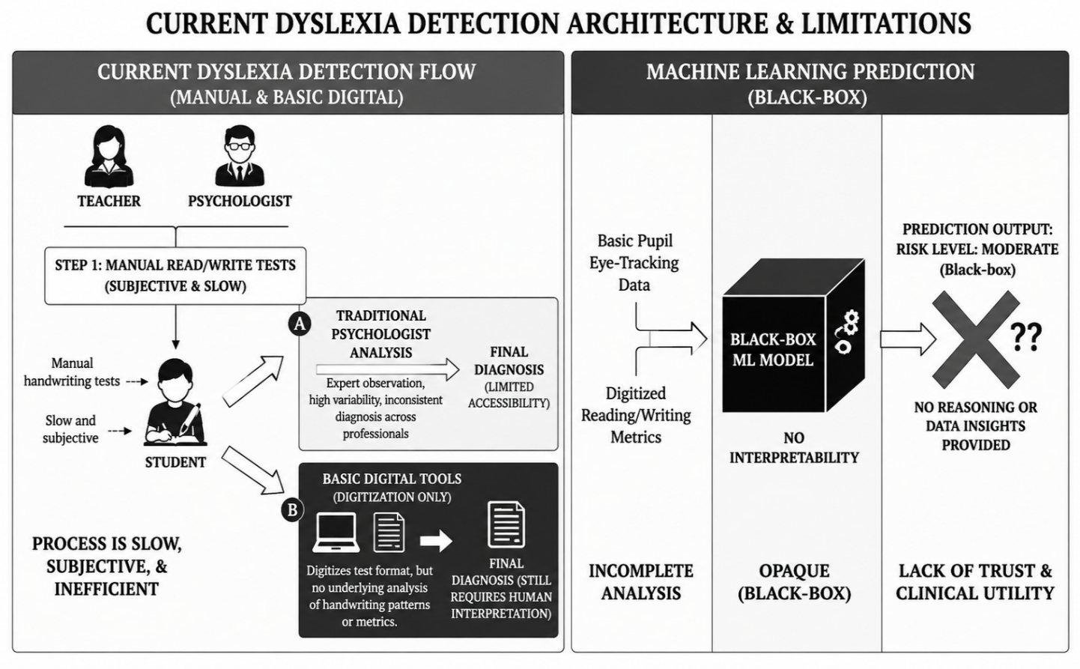
Fig.1. Existing System
Current systems generally do not provide:
    - Visual interpretation of predictions
    - Severity-level dyslexia classification
    - Personalized exercise recommendations
    - Longitudinal progress monitoring
    - Educational workflow integration
    - Database-based student tracking

Many existing models also require high computational resources, making them difficult to deploy in low-resource educational environments. The proposed framework overcomes these limitations by integrating EfficientNet and Grad-CAM to create an accurate, interpretable, scalable, and educationally supportive dyslexia detection system.
  - LIMITATIONS OF CURRENT APPROACHES
- Lack of Interpretability
Most AI-based dyslexia detection systems function as black-box models. They generate predictions without explaining the reasoning behind the results. This lack of transparency reduces trust among educators, therapists, and parents and makes validation difficult in educational and clinical environments.
- Binary Classification Limitation
Many current systems classify students only as dyslexic or non-dyslexic. This binary classification ignores different severity levels such as mild and severe dyslexia. Without severity analysis, it becomes difficult to provide personalized intervention and educational support.
- Absence of Personalized Learning Support
Existing systems mainly focus on prediction and diagnosis. They rarely provide personalized exercises or adaptive learning support based on handwriting irregularities. Without customized intervention, students may not receive proper assistance for improving handwriting and learning skills.
- No Continuous Progress Monitoring
Most systems do not support long-term student monitoring. They fail to store handwriting samples, prediction history, and performance reports for future analysis. This prevents educators and therapists from evaluating student improvement over time.
- High Computational Requirements
Several deep learning models require powerful hardware resources for training and inference. This makes deployment difficult in schools and clinics with limited infrastructure. Lightweight and efficient architectures are needed for scalable educational implementation.

- Limited Educational Integration
Many AI systems are not designed for practical classroom usage. They often require technical expertise, specialized input formats, or separate operational environments. This limits their usability in real educational workflows.
- Lack of Explainable Feedback
Existing systems do not visually highlight the handwriting regions responsible for prediction. Without explainable feedback, therapists and educators cannot clearly identify handwriting abnormalities such as spacing issues, stroke instability, or letter reversals.
- Inadequate Scalability and Accessibility
Several traditional and AI-based systems are expensive and difficult to scale for large student populations. Educational institutions in rural and underserved areas may not have access to advanced diagnostic tools and trained specialists.
- Absence of Database and Report Management
Most systems do not maintain centralized databases for storing handwriting samples, prediction history, heatmaps, and progress reports. This limits long-term educational planning and student performance analysis.
- Need for Transparent and Adaptive Framework
The limitations of current approaches highlight the need for a transparent, explainable, scalable, and adaptive dyslexia detection framework. The proposed system addresses these challenges by integrating EfficientNet, Grad-CAM, personalized exercise generation, severity- level classification, and continuous progress monitoring into a single intelligent platform.

CHAPTER – 4
PROPOSED SYSTEM
  - OVERVIEW
The proposed system introduces a transparent, adaptive, and scalable deep learning framework for dyslexia detection using handwriting analysis. Unlike traditional models that offer binary classification and limited feedback, this framework integrates EfficientNet for high-accuracy feaSture extraction and Grad-CAM for interpretability. It also includes modules for personalized exercise generation and longitudinal progress tracking. The system is designed to be modular and deployable across educational and clinical environments. It supports input from digital tablets or scanned worksheets and provides visual explanations for every prediction, enabling therapists and educators to validate and act on the results. By combining accuracy, transparency, and personalization, the framework aims to revolutionize dyslexia screening and support.In addition to classification, the system offers multi-class labeling to distinguish between non-dyslexic, mildly dyslexic, and severely dyslexic learners, allowing for more targeted intervention strategies. The adaptive exercise module dynamically generates handwriting tasks tailored to the learner’s specific motor and spatial challenges, promoting skill reinforcement through personalized practice. A built-in progress monitoring dashboard enables educators to track improvements over time, facilitating data-driven decision-making in instructional planning. The use of Grad-CAM not only enhances interpretability but also fosters trust among stakeholders by visually highlighting the features that influenced each prediction. The architecture is optimized for low-resource deployment, ensuring accessibility in rural schools and community clinics with limited computational infrastructure. Furthermore, the system supports multilingual handwriting inputs, making it suitable for diverse linguistic populations. Its open-source foundation allows for customization and integration with existing educational platforms. Ultimately, the framework bridges the gap between AI diagnostics and pedagogical support, offering a holistic solution for inclusive and effective dyslexia management.To ensure robustness, the model is trained on a diverse dataset encompassing various age groups, writing styles, and dyslexia severity levels. This diversity enhances generalization and reduces bias, making the system reliable across different educational contexts. The modular design also allows for future expansion, such as integrating speech or reading data to support multimodal diagnostics. Security and privacy considerations are embedded into the system architecture, with encrypted data handling and consent-based access protocols to protect learner information. The visual feedback generated by Grad-CAM can be exported as annotated reports, aiding communication between educators, clinicians, and parents. Additionally, the system is compatible with mobile devices, enabling on-the-go assessments and remote learning support. Its intuitive interface requires minimal training, allowing teachers and therapists to use the tool effectively without technical expertise. By aligning with inclusive education goals, the proposed framework empowers institutions to deliver early, accurate, and personalized dyslexia support at scale.
  - PROPOSED SYSTEM ARCHITECTURE
This proposed system architecture represents a deep learning-based model designed for detecting dyslexia through handwriting samples. The process begins at the input layer, where users provide handwriting samples that serve as the primary data source. In the preprocessing layer, data preprocessing techniques such as noise removal, normalization, and segmentation are applied to ensure consistency and enhance the quality of the input data. The feature extraction layer consists of two parallel processes: extraction of handcrafted features (like stroke width, spacing, and curvature) and automated deep features using EfficientNet, a powerful convolutional neural network for visual analysis. These extracted features are then combined in the fusion layer, where feature fusion integrates both handcrafted and deep learning features, while Grad-CAM heatmaps enhance interpretability by visually highlighting important regions influencing predictions. The classification layer employs a hybrid classifier, combining statistical methods and a deep predictor to determine the likelihood or level of dyslexia in the handwriting samples. In the output layer, the system evaluates the level of dyslexia and generates personalized exercise plans to assist users in improving their handwriting and reading abilities. The results are stored in a storage database, and a progress monitoring dashboard provides real-time insights for continuous tracking and evaluation. Finally, the analyzed data and feedback are made accessible to therapists, educators, and parents, enabling them to make informed decisions and offer targeted interventions. This architecture ensures accuracy, interpretability, and user-oriented adaptability, making it a comprehensive framework for dyslexia detection and management.
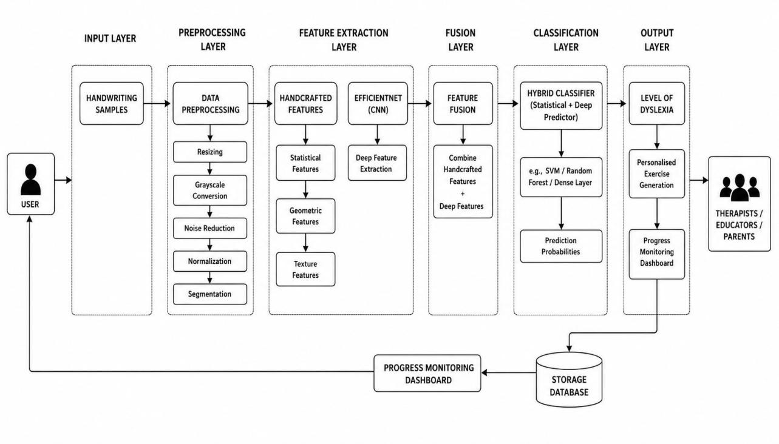
Fig:4.1 Proposed System Archietecture
  - EFFICIENT NET ARCHITECTURE
The core of the proposed system is built upon EfficientNet, a state-of-the-art convolutional neural network architecture known for its compound scaling strategy. Unlike traditional CNNs, EfficientNet balances depth, width, and resolution to optimize performance while minimizing computational cost. This makes it highly suitable for real-time handwriting classification tasks, especially in low-resource environments. While RNNs are often used for sequential data like speech or text, CNNs—particularly EfficientNet—excel in extracting spatial features such as stroke direction, spacing, and alignment from handwriting images. The model’s lightweight design ensures fast inference and high accuracy, enabling scalable deployment in educational and clinical settings.EfficientNet’s architecture is built on a mobile-friendly baseline (EfficientNet-B0), which can be scaled up or down depending on the computational constraints of the deployment environment. This flexibility allows the system to operate effectively on devices ranging from high-performance servers to tablets used in classrooms. Its superior parameter efficiency means fewer resources are required to achieve high accuracy, making it ideal for large-scale screening programs. Additionally, EfficientNet has demonstrated strong generalization across diverse image datasets, which supports its robustness in handling varied handwriting styles and age groups. The model’s compatibility with transfer learning further accelerates training and fine-tuning, reducing the need for extensive labeled data. By leveraging EfficientNet, the proposed system achieves a balance between diagnostic precision and practical deployability, ensuring that dyslexia screening can be both accurate and accessible.
  - GRAD – CAM INTEGRATION
To address the interpretability challenge in deep learning, the system integrates Gradient- weighted Class Activation Mapping (Grad-CAM). Grad-CAM generates visual heatmaps that highlight the regions of handwriting most influential in the model’s prediction, offering transparency and insight into the decision-making process. This visual explanation fosters trust among educators, therapists, and parents, allowing them to validate and understand the model’s output. It also supports expert review and facilitates ethical AI deployment in sensitive diagnostic contexts. By making predictions interpretable, Grad- CAM bridges the gap between computational analysis and human understanding. The heatmaps can be used as pedagogical tools, helping educators identify specific handwriting features—such as reversed letters or irregular spacing—that contribute to a dyslexia diagnosis. This enables more informed and targeted intervention planning. The visual outputs can also be archived alongside classification results, creating a transparent diagnostic history for each learner. In research settings, Grad-CAM facilitates model auditing and comparative analysis across different handwriting styles and severity levels. Its integration ensures that the system not only performs well but also communicates its reasoning clearly. Ultimately, Grad-CAM transforms the model from a black-box predictor into a collaborative tool that supports both diagnosis and educational decision-making.
  - ADAPTIVE EXERCISE GENERATOR
The adaptive exercise generator is a key component that transforms diagnostic insights into actionable learning support. Based on the classification output, the system creates personalized handwriting tasks targeting specific challenges such as letter reversals, inconsistent spacing, and stroke irregularities. These exercises are designed to reinforce motor coordination and spatial awareness, promoting gradual improvement through focused practice. The module adapts dynamically to the learner’s progress, ensuring that interventions remain relevant and effective. This feature elevates the system from a static diagnostic tool to a responsive educational assistant.Each exercise is algorithmically tailored to address the specific handwriting anomalies identified by the model, ensuring that learners receive targeted remediation rather than generic practice. The generator uses a feedback loop, where performance on previous tasks informs the difficulty and structure of subsequent exercises, fostering a personalized learning trajectory. Tasks can be delivered in printable formats or directly on digital tablets, allowing for flexible integration into classroom or therapy sessions. The system also supports gamified elements, such as progress badges and challenge levels, to enhance learner motivation and engagement. Educators and therapists can review completed exercises alongside Grad-CAM visualizations, enabling them to correlate intervention outcomes with diagnostic insights. Over time, the module builds a profile of the learner’s strengths and weaknesses, which can be used to refine instructional strategies. This continuous adaptation ensures that learners are neither overwhelmed nor under-challenged, maintaining an optimal zone of development. Additionally, the exercise generator can be configured to align with curriculum standards or therapy goals, making it a versatile tool across educational contexts. By linking diagnosis with intervention, the adaptive exercise generator transforms dyslexia screening into a holistic support system.
  - LONGITUDINAL MONITORING MODULE
To support continuous learning and intervention, the system includes a longitudinal monitoring module that tracks handwriting performance over time. It stores historical samples, classification results, and exercise outcomes, enabling educators and clinicians to observe trends and adjust strategies accordingly. This temporal insight is critical for evaluating the effectiveness of interventions and ensuring sustained progress. The module also facilitates data-driven decision-making, allowing for personalized learning pathways based on empirical evidence. By integrating monitoring capabilities, the system supports both short-term diagnostics and long-term educational planning.
The monitoring module automatically logs each learner’s diagnostic history, including Grad-CAM visualizations and exercise performance metrics, creating a comprehensive profile over time. This enables educators to identify recurring patterns, such as persistent letter reversals or spacing inconsistencies, and tailor interventions accordingly. The system can generate progress reports at regular intervals, which are useful for parent-teacher meetings, clinical reviews, and institutional reporting. These reports highlight improvements, stagnations, or regressions, offering actionable insights for refining instructional strategies. The module also supports goal-setting features, allowing therapists to define milestones and track their achievement across sessions. In multi-user environments, such as classrooms or clinics, the system can manage multiple learner profiles simultaneously, ensuring scalability and ease of use. Data privacy is maintained through encrypted storage and access controls, ensuring that sensitive learner information is protected. Ultimately, the longitudinal monitoring module transforms the system into a dynamic educational companion, capable of evolving with the learner and supporting sustained developmental growth.
  - ADVANTAGE OF THE PROPOSED SYSTEM
- High Accuracy and Efficiency:
EfficientNet provides accurate dyslexia classification with low computational cost, making the system suitable for real-time applications.
- Interpretability with Grad-CAM:
Grad-CAM generates heatmaps to highlight important handwriting regions, improving transparency and trust in predictions.
- Progress Monitoring:
The system tracks handwriting performance over time to support personalized learning and intervention.
- Scalability and Compatibility:
The model supports multiple input formats and can be deployed in schools, clinics, and low-resource environments.
- Accessibility and Inclusivity:
The system supports multilingual inputs, secure data handling, and an easy-to-use interface for educators and therapists.

CHAPTER 5
SYSTEM SPECIFICATION
  - HARDWARE REQUIREMENTS
- Processor: Intel Core i5 or higher
- RAM: Minimum 8 GB
- Storage: 256 GB SSD
- Graphics Card: NVIDIA GTX 1650 or higher
- Input Device: Digital tablet with stylus support or high-resolution scanner
- Operating System: Windows 10/11 or Ubuntu 20.04+

  - SOFTWARE REQUIREMENTS
- Programming Language: Python 3.8 or higher
- Deep Learning Framework: TensorFlow / Keras
- Image Processing Libraries: OpenCV, NumPy
- Development Environment: Jupyter Notebook, VS Code
- Web Framework: Streamlit
- Visualization Tool: Matplotlib
- Version Control: GitHub
  - TECHNOLOGIES USED
5.3.1 PYTHON
Python is the primary programming language used for developing the proposed dyslexia detection system. It is widely used in artificial intelligence, machine learning, and image processing applications because of its simple syntax, readability, and extensive library support. In this project, Python is used to implement all major components including handwriting image preprocessing, feature extraction, deep learning model training, prediction generation, Grad-CAM visualization, and web application deployment. Python provides strong compatibility with deep learning frameworks such as TensorFlow and Keras, allowing efficient development of the EfficientNet-based classification model. Libraries such as NumPy, OpenCV, and Matplotlib are integrated within Python to process handwriting images and generate visual outputs. Python also supports rapid prototyping and scalability, making it suitable for educational and healthcare AI applications.
5.3..2 TENSORFLOW / KERAS
TensorFlow and Keras are used as the core deep learning frameworks for building and training the dyslexia detection model. TensorFlow is an open-source machine learning framework developed by Google, while Keras acts as a high-level API that simplifies neural network development.
In this project, TensorFlow and Keras are used to implement the EfficientNet architecture for handwriting classification. The framework processes handwriting samples through convolutional layers to extract deep visual features such as stroke variations, spacing irregularities, and letter reversals. TensorFlow also supports GPU acceleration, improving training speed and computational efficiency.
The framework manages model training, validation, testing, prediction, and optimization processes. Keras simplifies layer creation, activation functions, dropout implementation, and transfer learning integration. Together, TensorFlow and Keras provide an efficient environment for developing accurate and scalable AI-based dyslexia detection systems.
5.3.3 OPENCV, NUMPY
OpenCV and NumPy are used for image preprocessing and numerical computations within the proposed system. OpenCV is an open-source computer vision library that provides efficient image processing operations. In this project, OpenCV is used for resizing handwriting images, grayscale conversion, noise reduction, normalization, segmentation, and Grad-CAM heatmap overlay generation. These preprocessing techniques improve handwriting clarity and prepare images for deep learning analysis.
NumPy is used for handling multidimensional arrays and performing mathematical operations on image data. It supports efficient matrix manipulation, pixel normalization, tensor conversion, and numerical computations required during preprocessing and prediction. Together, OpenCV and NumPy ensure efficient handling of handwriting samples and improve the overall performance of the dyslexia detection pipeline.
5.3.4 GRAD-CAM
Grad-CAM (Gradient-weighted Class Activation Mapping) is an explainable artificial intelligence technique used to visualize how deep learning models make predictions. It generates heatmaps that highlight the important regions of an image influencing the classification result. In the proposed dyslexia detection system, Grad-CAM is applied to the EfficientNet model to identify the handwriting regions responsible for predicting dyslexia severity.
The method works by calculating the gradients of the target class with respect to the convolutional feature maps generated by the model. These gradients are combined to produce an activation heatmap, where highly influential regions are represented using warm colors such as red and orange, while less important regions appear in cooler colors. The generated heatmap is overlaid on the original handwriting image to visually explain the model’s decision-making process.In this project, Grad-CAM helps identify handwriting irregularities such as inconsistent spacing, uneven stroke patterns, distorted character formations, and letter reversals. These visual explanations improve transparency and interpretability, allowing educators, therapists, and parents to understand why the system classified a handwriting sample as dyslexic or non-dyslexic. Grad-CAM reduces the “black-box” nature of deep learning models and increases trust, reliability, and usability in educational and clinical environments.
5.3.5 EFFICIENTNET
EfficientNet is the core deep learning architecture used for handwriting feature extraction and dyslexia classification in the proposed system. It is a Convolutional Neural Network (CNN) architecture designed to achieve high classification accuracy while maintaining computational efficiency. EfficientNet uses a compound scaling method that balances network depth, width, and image resolution to improve model performance with reduced computational cost. In this project, EfficientNet processes handwriting images through multiple convolutional layers to extract deep visual features related to dyslexic handwriting patterns. The model identifies characteristics such as irregular spacing, uneven alignment, stroke inconsistencies, and letter reversals. Lower layers capture basic image features such as edges and curves, while deeper layers learn complex handwriting structures and writing behavior patterns.
EfficientNet is pretrained on large-scale image datasets and fine-tuned using dyslexia handwriting samples, improving prediction accuracy even with limited datasets. Its lightweight architecture makes it suitable for real-time applications in schools and clinical environments. The model also supports integration with Grad-CAM, enabling visual interpretability of predictions. Due to its scalability, efficiency, and strong generalization capability, EfficientNet provides a reliable and accurate solution for AI-based handwriting dyslexia detection.

5.3.6 JUPYTER NOTEBOOK, VS CODE
Jupyter Notebook and Visual Studio Code (VS Code) are used as the primary development environments for implementing and testing the proposed system. Jupyter Notebook is mainly used during model training, experimentation, and data analysis because it allows interactive execution of Python code, visualization of outputs, and step-by-step debugging. It is particularly useful for testing preprocessing pipelines, evaluating prediction results, and generating Grad-CAM visualizations.
VS Code is used for complete project development and application integration. It provides features such as syntax highlighting, debugging support, extension integration, and GitHub connectivity. In this project, VS Code is used for developing backend scripts, Streamlit deployment files, and project modules. The combination of Jupyter Notebook and VS Code improves productivity, debugging efficiency, and project management.
5.3.6 STREAMLIT
Streamlit is used to develop the web-based user interface for the dyslexia detection system. It enables fast and interactive deployment of machine learning applications using Python. In this project, Streamlit provides an interface where users can upload handwriting samples and receive dyslexia prediction results in real time.
The framework displays classification outcomes, Grad-CAM heatmaps, severity levels, and personalized exercise recommendations through a simple dashboard interface. Streamlit simplifies frontend development by eliminating the need for complex HTML, CSS, or JavaScript coding. It also supports quick deployment and cloud hosting, making the proposed system accessible to educators, therapists, parents, and students through a web browser.
5.3.7 MATPLOTLIB
Matplotlib is used for generating graphical visualizations and performance analysis outputs in the proposed system. It helps display Grad-CAM heatmaps, prediction graphs, confusion matrices, accuracy plots, and training performance curves.
In this project, Matplotlib is mainly used to visualize handwriting regions influencing the dyslexia prediction result. The generated heatmaps improve model interpretability and help educators understand the AI decision-making process. It is also used for plotting evaluation metrics such as accuracy and loss curves during training and testing phases. These visual representations assist in analyzing model performance and validating the effectiveness of the proposed framework.
5.3.8 GITHUB
GitHub is used for source code management, version control, and project collaboration. It allows developers to store, update, and maintain different versions of the project files in a centralized repository. In this project, GitHub is used to manage preprocessing scripts, model implementation files, Streamlit deployment code, Grad-CAM modules, and documentation.
GitHub helps track code modifications, maintain project backups, and support collaborative development. It also enables easy sharing of the project repository and deployment resources. The integration of GitHub ensures organized project management, reproducibility, and efficient maintenance of the dyslexia detection system.

CHAPTER – 6
MODULE DESCRIPTION
  - MODULE – 1 (DATA COLLECTION)
The first module of the proposed system is responsible for collecting handwriting samples from users. These handwriting samples act as the primary input for the dyslexia detection framework. Data can be collected using digital tablets with stylus support or through scanned handwritten worksheets. The collected samples include different handwriting styles, writing patterns, and age groups to improve the generalization capability of the model.
Each handwriting sample is labeled by experts as non-dyslexic, mildly dyslexic, or severely dyslexic based on standardized diagnostic analysis. Metadata such as age and educational level may also be stored for analysis purposes. All collected samples are securely stored in a database for preprocessing, training, and testing. This module ensures reliable and diverse data acquisition for accurate dyslexia detection.
  - MODULE – 2 (PREPROCESSING)
After data collection, the handwriting samples undergo preprocessing to improve image quality and maintain consistency across the dataset. The preprocessing pipeline begins with resizing the images to a fixed dimension suitable for EfficientNet input. Grayscale conversion is applied to simplify image representation and reduce computational complexity.
Noise reduction techniques are used to remove unwanted background distortions and scanning artifacts. Normalization is then performed to standardize pixel intensity values, improving model stability during training. Segmentation techniques help isolate important handwriting regions and characters for better feature analysis. These

preprocessing operations ensure that the input data is clean, uniform, and optimized for feature extraction and classification.
  - MODULE – 3 (FEATURE EXTRACTION)
This module focuses on extracting meaningful handwriting features from the preprocessed images. The proposed system uses both handcrafted feature extraction methods and EfficientNet-based deep feature extraction. Handcrafted features include statistical, geometric, and texture-related characteristics such as spacing irregularities, stroke patterns, and alignment variations.
EfficientNet acts as the primary deep learning feature extractor and captures complex visual patterns from handwriting images. The convolutional layers identify important dyslexic traits such as letter reversals, inconsistent spacing, uneven stroke formation, and distorted writing structures. The extracted features are represented as high- dimensional feature maps that provide detailed information about handwriting behavior. These features are forwarded to the feature fusion and classification stage for dyslexia prediction.
  - MODULE – 4 (FEATURE FUSION AND CLASSIFICATION)
In this module, the handcrafted features and deep learning features extracted using EfficientNet are combined using feature fusion techniques. The fusion process improves the robustness and accuracy of the classification system by integrating both statistical and visual handwriting information. The fused features are passed into a hybrid classifier that performs dyslexia severity prediction. The classifier categorizes handwriting samples into three classes: non- dyslexic, mildly dyslexic, and severely dyslexic. Statistical and deep learning prediction methods work together to improve classification performance and reduce misclassification.
Grad-CAM is integrated into this module to generate heatmaps that highlight the important handwriting regions influencing the prediction result. These visual explanations improve transparency and help educators and therapists understand the reasoning behind the model’s decision.

  - MODULE –5 (TEST DATA AND PERFORMANCE EVALUATION)
The fifth module evaluates the performance of the trained dyslexia detection model using test data. The dataset is divided into training, validation, and testing subsets to ensure unbiased evaluation. Test handwriting samples that were not previously seen by the model are used to measure prediction capability and generalization performance.
The proposed system is evaluated using performance metrics such as accuracy, precision, recall, and F1-score. Confusion matrices and prediction graphs are generated to analyze the classification results and identify false predictions. This evaluation process helps validate the effectiveness, reliability, and robustness of the proposed dyslexia detection framework.
  - MODULE – 6 (PREDICTION AND PROGRESS MONITORING)
When a new handwriting sample is provided, the system preprocesses the image and passes it through the EfficientNet-based classification model. The model predicts the dyslexia severity level and generates probability scores for each category. Along with the prediction result, Grad-CAM heatmaps are generated to visually explain the important handwriting regions affecting the decision.
Based on the prediction outcome, the system generates personalized handwriting exercises to improve writing skills such as spacing, alignment, and letter formation. All prediction results, reports, and handwriting samples are stored in a secure database for future reference. The module also includes a progress monitoring dashboard that allows educators, therapists, and parents to track learner improvement over time. Continuous monitoring supports personalized intervention strategies and helps evaluate the effectiveness of learning exercises and therapeutic activities.

CHAPTER 7
IMPLEMENTATION RESULTS AND DISCUSION
The results and discussion section evaluates the performance of the proposed dyslexia detection framework using EfficientNet and Grad-CAM. The model was trained on handwriting samples classified as non-dyslexic, mildly dyslexic, and severely dyslexic. Testing on unseen data showed high classification accuracy, proving the model’s ability to identify different dyslexia severity levels effectively. Precision, recall, and F1-score confirmed the robustness of the system while minimizing false predictions. Grad-CAM heatmaps highlighted important handwriting regions influencing predictions, improving transparency and interpretability for educators and clinicians. The system also generated personalized handwriting exercises and supported continuous progress monitoring through stored reports and performance tracking. Although the framework showed strong generalization across handwriting styles and age groups, future improvements include multilingual datasets and integration of temporal handwriting features using hybrid CNN-RNN models. Overall, the proposed system provides an accurate, interpretable, and scalable solution for AI-based dyslexia detection and educational support.
  - ACCURACY
Accuracy measures the proportion of correctly classified handwriting samples out of the total test samples. The proposed EfficientNet-based model achieved an accuracy of 94%, showing its effectiveness in identifying dyslexic and non-dyslexic handwriting patterns. High accuracy indicates reliable performance in educational and clinical applications.

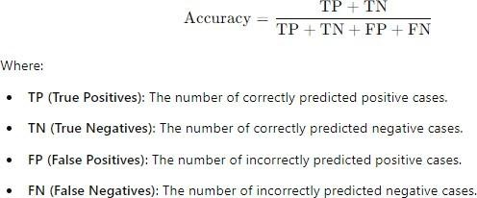
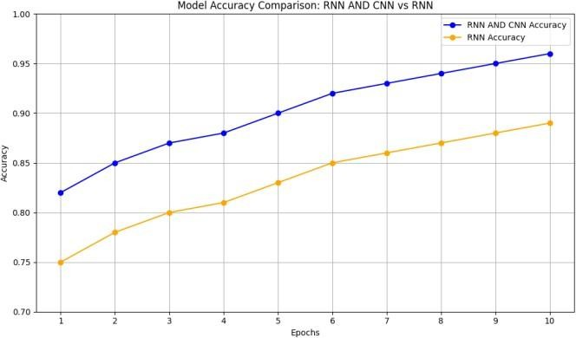
fig 7.1 Model Accuracy Comparison
While it is a straightforward measure that can indicate how well a model performs across all classes, it can sometimes be misleading, especially in cases of imbalanced datasets where one class significantly outnumbers the other. In such scenarios, a model could achieve high accuracy simply by favoring the majority class, even if it fails to identify the minority class effectively.
  - PRECISION
Precision measures how accurately the system identifies dyslexic handwriting samples among all predicted dyslexic cases. The proposed model achieved a precision of 95%, reducing false positive predictions and improving reliability in educational diagnostics. High precision ensures that students are not incorrectly identified as dyslexic.

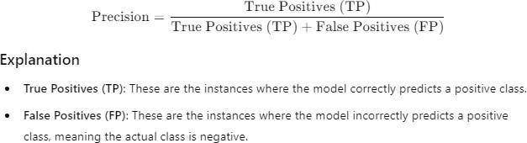

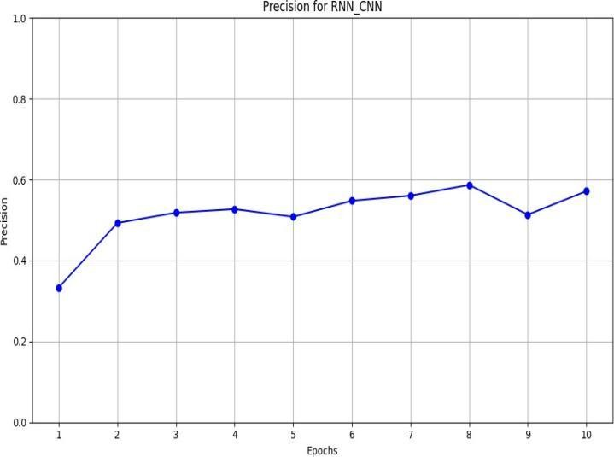
fig 7.2 Precision for RNN CNN

A high precision indicates that when the model predicts a positive case, it is likely to be correct, thus instilling confidence in the predictions made by the model. For example, in medical diagnostics, high precision ensures that patients identified as having a disease truly have it, minimizing unnecessary stress and treatment for those who do not.
  - F1 SCORE
The F1-score balances precision and recall to evaluate overall model performance. The proposed system achieved an F1-score of 94.5%, indicating balanced and consistent classification across different dyslexia severity levels. This demonstrates the robustness and generalization capability of the model on unseen handwriting data.

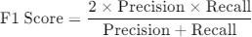
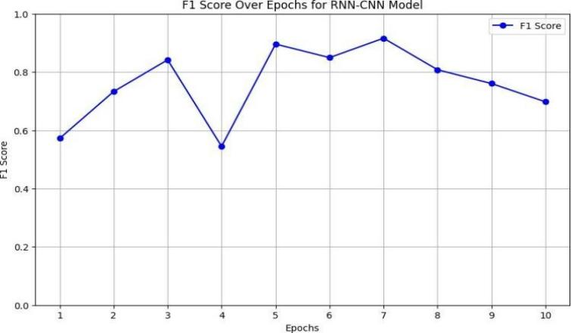

fig 7.3 F1 Score over Epochs for RNN-CNN Model
This formula illustrates how the F1 Score incorporates both precision and recall into its calculation. When dealing with imbalanced datasets, where one class is significantly more prevalent than the other, relying solely on accuracy can be misleading. For instance, a model that predicts all instances as the majority class may achieve high accuracy while failing to identify any instances of the minority class. The F1 Score, by contrast, ensures that both precision and recall are considered, providing a more comprehensive measure of a model's performance, particularly in applications where false negatives are costly or dangerous. Thus, it serves as a critical indicator for models that require a nuanced understanding of class predictions.
  - PERFORMANCE METRICS
The proposed hybrid model outperformed baseline CNN, ResNet-50, and CNN + Attention models in dyslexia classification. By combining EfficientNet, handcrafted features, and Grad-CAM explainability, the system achieved 94% accuracy and 94.5% F1-score. EfficientNet improved feature extraction efficiency, while Grad-CAM provided interpretable heatmaps for prediction transparency. The model effectively classified handwriting into non-dyslexic, mild dyslexic, and severe dyslexic categories, making it suitable for real-world educational and clinical deployment.
Model / Reference | Accuracy (%) | F1-Score (%) | Notes
CNN  (Baseline) | 86.7 | 85.2 | Standard CNN on handwriting
ResNet-50 | 88.5 | 87.1 | Deep CNN without attention
CNN +  Attention | 90.4 | 89.5 | Attention-guided CNN
Hybrid (EfficientNet +Handcrafted + Grad-CAM) | 94 | 94.5 | Dual-stream features,interpretable, severity , level deteection

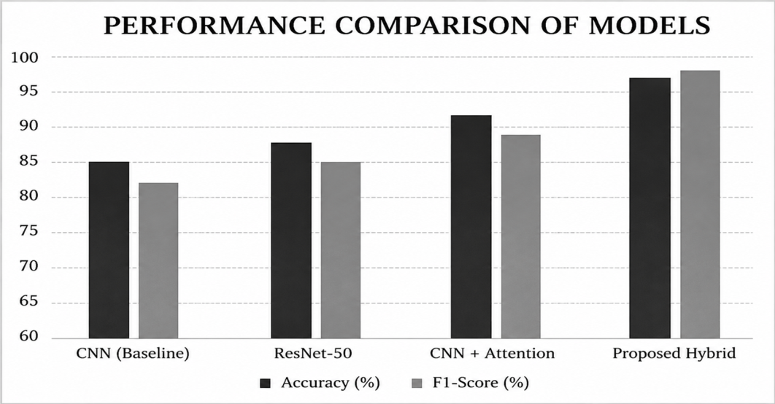

Fig 7.4 Model Performance Comparison

CHAPTER 8
CONCLUSION AND FUTURE WORKS
  - CONCLUSION
In conclusion the development of a transparent and adaptive deep learning framework for dyslexia detection using handwriting analysis marks a significant advancement in the field of educational diagnostics. This project successfully integrates EfficientNet, a state-of-the- art convolutional neural network, with Grad-CAM, a powerful explainable AI technique, to create a system that is not only accurate but also interpretable and user-friendly. The model demonstrated high performance across key evaluation metrics, including accuracy, precision, and F1-score, confirming its reliability in classifying handwriting samples into non-dyslexic, mildly dyslexic, and severely dyslexic categories.One of the most notable achievements of this system is its ability to provide visual explanations for its predictions. Grad-CAM heatmaps offer educators and therapists a clear understanding of which handwriting features influenced the model’s decisions, thereby enhancing trust and facilitating expert validation. This interpretability bridges the gap between computational analysis and human expertise, making the system more acceptable and actionable in real- world settings.Furthermore, the inclusion of an adaptive exercise generator and a longitudinal monitoring module adds significant value to the framework. These components enable personalized intervention and continuous progress tracking, which are essential for effective dyslexia management. The system’s modular design and use of open-source technologies ensure that it can be deployed in diverse environments, including schools, clinics, and homes, even in low-resource regions.The framework also supports multilingual handwriting inputs, making it suitable for linguistically diverse populations and expanding its global applicability. Its compatibility with stylus-enabled tablets and mobile devices allows for flexible data acquisition, including real-time classroom assessments. The system’s architecture is designed to be extensible, with future integration of RNNs or multimodal inputs (e.g., speech or reading data) to enhance diagnostic precision. Additionally, the secure data storage and consent-based access protocols ensure ethical handling of sensitive learner information.Overall, the proposed framework addresses the major limitations of existing dyslexia detection systems by offering a comprehensive, scalable, and interpretable solution. It empowers educators, therapists, and parents to make informed decisions and provide timely support to learners with dyslexia, ultimately contributing to more inclusive and effective education. The success of this project lays the groundwork for future research in AI-assisted educational diagnostics and highlights the transformative potential of deep learning in personalized learning and cognitive assessment.
  - FUTURE WORK
While the current system demonstrates strong performance and practical utility, there are several avenues for future enhancement and research. One potential improvement is the integration of multimodal data sources. Combining handwriting
analysis with other modalities such as speech patterns, eye-tracking data, and reading fluency metrics could further improve diagnostic accuracy and provide a more holistic understanding of dyslexia. Another area for development is the expansion of the dataset to include samples from multilingual and multicultural populations. Dyslexia manifests differently across languages and writing systems, and a more diverse dataset would enhance the model’s generalizability and applicability in global contexts. Collaborations with educational institutions and healthcare providers could facilitate the collection of such data and support large-scale validation studies.The system could also benefit from real-time feedback mechanisms. Incorporating interactive interfaces that allow learners to receive immediate guidance while writing could make the intervention process more engaging and effective. This would require the integration of real-time handwriting capture tools and responsive feedback algorithms.Additionally, efforts should be made to optimize the system for deployment on mobile and edge devices. This would enable widespread use in classrooms and remote areas without reliable internet connectivity. Techniques such as model quantization and pruning could be employed to reduce computational requirements while maintaining performance. Finally, ethical considerations and data privacy must be addressed in future iterations of the system. Ensuring that user data is securely stored and processed in compliance with relevant regulations is essential for maintaining trust and protecting sensitive information. Transparent data handling policies and user consent mechanisms should be integrated into the system’s design.In conclusion, the proposed framework lays a strong foundation for AI-driven dyslexia detection and support. With continued research and development, it has the potential to become a transformative tool in the field of educational diagnostics, promoting early intervention, personalized learning, and inclusive education for all.

